**Safeguarding Adults**

**What to Expect**

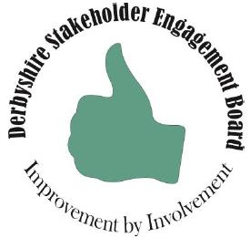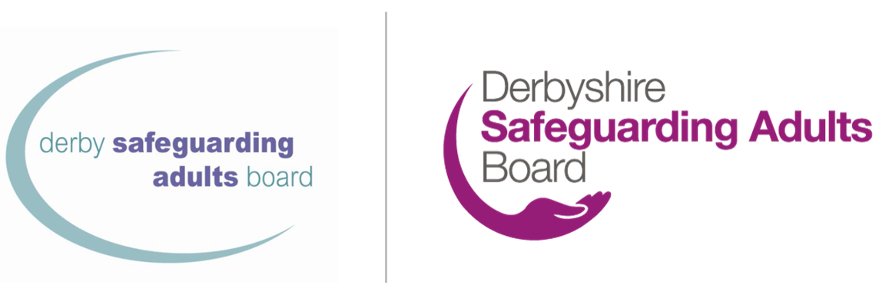

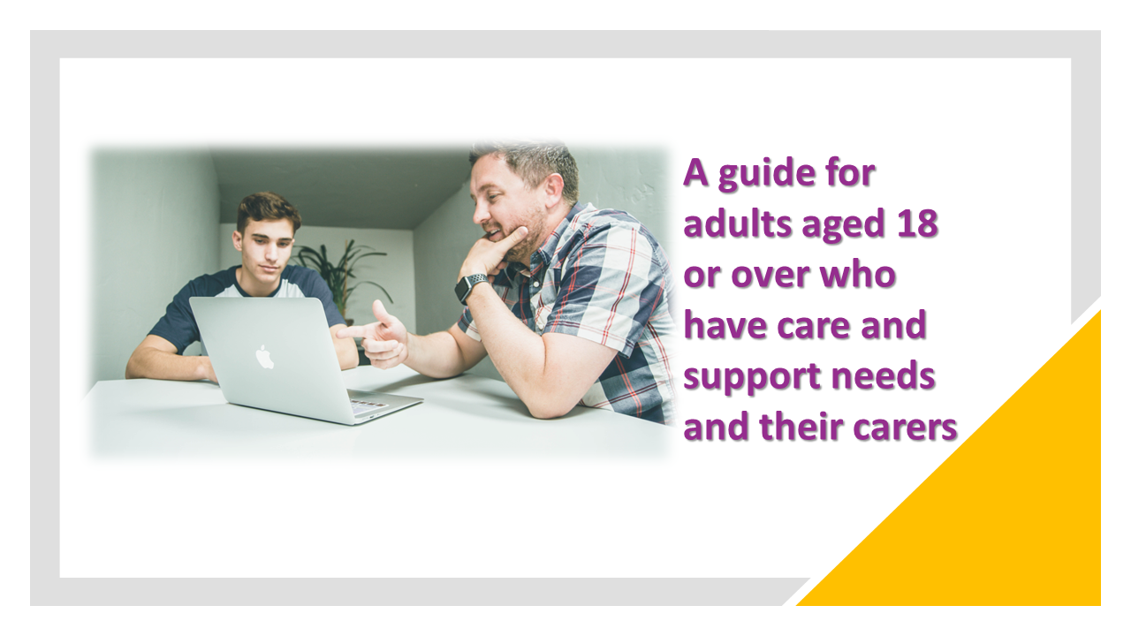

|  |
| --- |
| Your main point of contact for the safeguarding process is: |

|  |
| --- |
| They can be contacted on: Phone:  Email:  Emergency phone:  Out of hours phone: |

# Why you have been given this leaflet

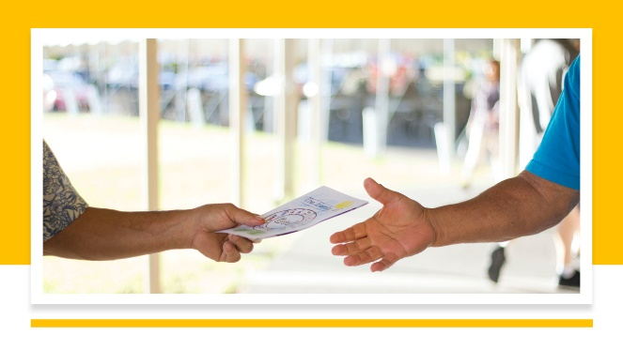There have been some concerns about your safety and wellbeing, and we would like to support you to stay safe. This support is called safeguarding. If you are a carer you have been given this leaflet as there are concerns about the safety and wellbeing of the person you care for.

Everyone has the right to live free from harm and neglect.

We may be told that a person is being hurt or abused. When there are concerns raised, we then try to find out what has happened.

|  |
| --- |
| At the moment we are concerned about: |

# What to expect: adult safeguarding

Two people sitting on a sofa giving the thumbs-up sign.


* We will speak to you or ask other agencies to speak to you about how you want to stay safe.
* With you and/or your representative we will develop a plan to keep you safe.
* Different organisations maybe involved in this plan, and they will have tasks they need to complete with you or for you.
* You may be invited to a safeguarding meeting where you and all the professionals who could support you can help.
* If you have difficulty making decisions or understanding information about the safeguarding process, we will work with you in your best interests where it is necessary.
* At the end of the safeguarding process, we would like to know how you felt it went.
* Throughout the safeguarding process your wellbeing, safety and rights are our priority.

|  |
| --- |
| Organisations who might be involved in helping to support you in safeguarding: |

# Your views/your carer’s views



Please record your views here. If you are a carer, please help the person you care for to complete this section of the form, or if they are unable to complete it you can complete it on their behalf.

If you like, you can share this with your main contact.

You could record:

* Your views on the risks that have been identiﬁed
* What you would like to happen in future to help you keep safe
* What you think local agencies can do to support you
* Anything else you think the agencies should know

|  |
| --- |
| Write your views here (if you are a carer please state this below): |

# Your Information



You will be given information in a way we hope you can understand.

You will know what is happening and have your views taken into account.

You can have someone of your choice to support you. An advocate can help you say what you want to say. They can help make sure other people consider your views.

* In Derbyshire independent advocacy support is provided by [Cloverleaf Advocacy](https://cloverleaf-advocacy.co.uk/areas/derbyshire), phone 01924 454875
* In Derby City independent advocacy support is provided by [One Advocacy](https://www.citizensadvicemidmercia.org.uk/advocacy/), phone 01332 228748

Your information may need to be shared with others this may include NHS professionals or the police. We will only share information when it is necessary and in line with [Derbyshire County Council privacy notices](https://www.derbyshire.gov.uk/council/gdpr/privacy-notices/privacy-notices.aspx) and [Derby City Council privacy notices](https://www.derby.gov.uk/site-info/privacy-notices/about/).

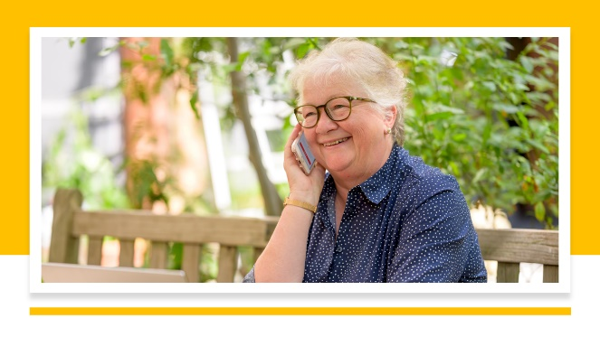

# Other Contacts

* [Police](https://www.derbyshire.police.uk/) – in an emergency phone 999; non-emergency phone 101
* [Call Derbyshire](https://www.derbyshire.gov.uk/council/contact-us/call-derbyshire/call-derbyshire.aspx) – 01629 533190
* [Derbyshire Safeguarding Adults Board](https://www.derbyshiresab.org.uk/home.aspx) website [Derby City Adult Care](https://www.derby.gov.uk/site-info/privacy-notices/about/) website or phone 01332 640777
* [Derby City Council Multi-Agency Safeguarding Hub (MASH)](https://www.derby.gov.uk/health-and-social-care/safeguarding-adults-at-risk/safeguarding-vulnerable-adults/#page-6) - phone 01332 642855, fax 01332 643299
* [Age UK Derby and Derbyshire](https://www.ageuk.org.uk/derbyandderbyshire/) – phone 01773 766922
* [Community Action Derby](https://www.communityactionderby.org.uk/) – phone 01332 346266
* [CVS (Community Voluntary Support) – Amber Valley](https://avcvs.org/) – phone 01773 512076
* [CVS (Community Voluntary Support) – Bolsover-Bassetlaw](https://www.bcvs.org.uk/) – phone 01246 605075 (Bolsover) or 07923 256 973 (Bassetlaw)
* CVS (Community Voluntary Support) – Chesterfield and North Derbyshire LINKS – phone 01246 274844, email [linkscvs@btconnect.com](mailto:linkscvs@btconnect.com)
* [CVS (Community Voluntary Support) – Derbyshire Dales](https://www.ddcvs.org.uk/) – phone 01629 812154
* [CVS (Community Voluntary Support) – Erewash](https://www.erewashvoluntaryaction.org.uk/) – phone 01159 466740
* [CVS (Community Voluntary Support) – High Peak](https://highpeakcvs.org.uk/) – phone 01663 735350
* [CVS (Community Voluntary Support) – South Derbyshire](https://www.sdcvs.org.uk/) – phone 01283 219761
* [Derby Drug and Alcohol Recovery Service](https://derbydrugandalcohol.nhs.uk/) – phone 0300 790 0265
* [Derbyshire Carers Association](https://derbyshirecarers.co.uk/) – phone 01773 833 833
* Derbyshire Domestic Abuse Helpline is a specialist helpline for all victims of domestic abuse – phone 0800 019 8668, text 07534 617 252
* [Derbyshire LGBT+](https://www.derbyshirelgbt.org.uk/) provides specialist support for LGBT people in Derbyshire – phone 01332 207704
* [Derbyshire Recovery Partnership](https://www.derbyshirehealthcareft.nhs.uk/services/drugs-and-alcohol-support/derbyshire-recovery-partnership) (drug and/or alcohol)
* Derbyshire Victim Services – phone 0808 612 6505
* [Modern Slavery Helpline](https://www.modernslaveryhelpline.org/) – phone 0800 0121 700
* [National Domestic Abuse Helpline](https://www.nationaldahelpline.org.uk/) ([Refuge](https://refuge.org.uk/?gclid=EAIaIQobChMIp9mUtNeZ_QIVC-vtCh1NjQiNEAAYASAAEgJjpvD_BwE) and [Women’s Aid](https://www.womensaid.org.uk/)) – phone 0808 2000 247
* [Rape Crisis](https://rapecrisis.org.uk/) – phone 0808 802 9999
* [SAIL (Sexual Abuse and Incest Line)](https://www.sailderbyshire.org.uk/) – phone 0800 028 2678, text 07522 561397
* [Samaritans](https://www.samaritans.org/how-we-can-help/contact-samaritan/?utm_source=google&utm_medium=organic&utm_campaign=onebox) – phone 116 123
* [Stop Hate UK](https://www.stophateuk.org/) – phone 0800 138 1625
* [SV2](https://www.sv2.org.uk/help-support/) supports victims of sexual violence – phone 01773 746115
* [Victim Support UK](https://www.victimsupport.org.uk/help-and-support/?gclid=EAIaIQobChMIiP3RpdiZ_QIVzO3tCh2zugs7EAAYASAAEgIhSPD_BwE) – phone 08 08 16 89 111

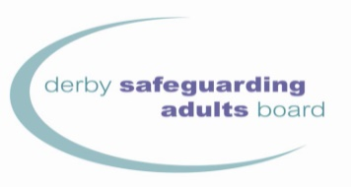

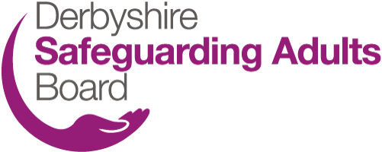

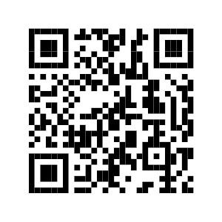

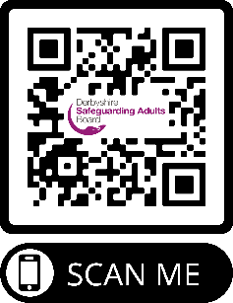

To use the QR codes

1. Open the camera app.
2. Select the rear-facing camera in Photo mode.
3. Centre the QR code you want to scan on the screen and hold your phone steady for a couple of seconds.
4. Tap the notification that pops up to open the link (you will need to be connected to the internet to do this).

[www.derbysab.org.uk](http://www.derbysab.org.uk) [www.derbyshiresab.org.uk](http://www.derbyshiresab.org.uk)

If you would like to receive this leaflet in a different language or format, please email [DerbyshireSAB@derbyshire.gov.uk](mailto:DerbyshireSAB@derbyshire.gov.uk) for Derbyshire residents and [DSAB@derby.gov.uk](mailto:DSAB@derby.gov.uk) for Derby City residents.

