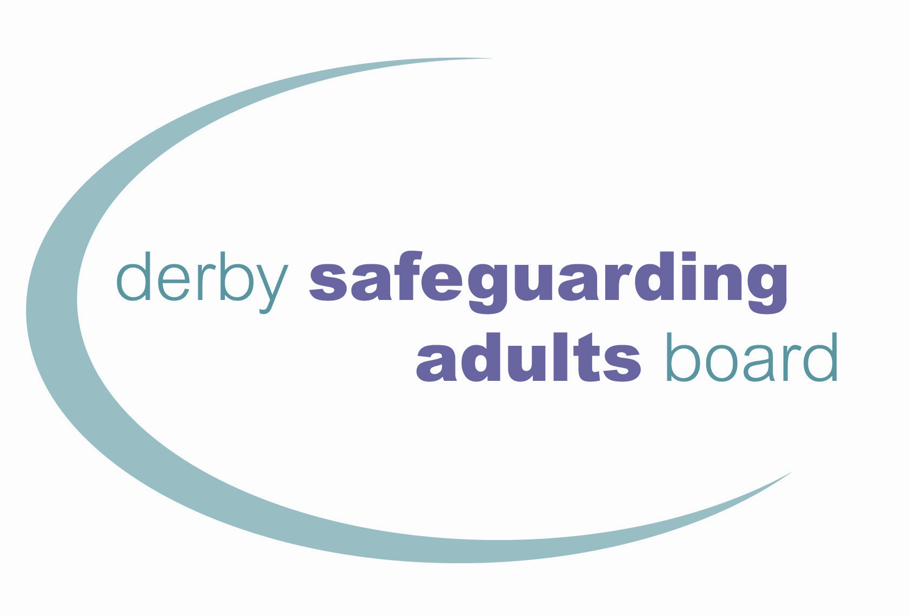

Dear Colleague,

**Derby & Derbyshire Dignity Campaign:** [**http://www.derbysab.org.uk/dignityandrespect.asp**](http://www.derbysab.org.uk/dignityandrespect.asp)

The Derby & Derbyshire Dignity Campaign is a Derby City Safeguarding Adult Board initiatitve. It encourages people to register as Dignity Champions. Many Champions are making a practical difference through improvements, often cost free. Promoting dignity is about practical changes making an impact at the face to face point of service delivery.

This is what we want you to do as a Champion in Derby/Derbyshire:

* 1. **Use your passion and commitment to improve outcomes for vulnerable people in contact with your team.**
  2. **Use influence available through your job to challenge bad practice and raise the profile of dignity and respect issues.**
  3. **Work to tackle, not tolerate, poor practice.**
  4. **Share with other champions, knowledge, expertise, experiences and enthusiasm through the website (http://www.derbysab.org.uk/dignityandrespect.asp)**
  5. **Gather evidence with your team to achieve and maintain the Derby City dignity award**.

So specifically we ask you to:

**REGISTER AS A CHAMPION(S)** At least one team member needs to register as a dignity champion via the national website by clicking on

[User Registration - User Account - Dignity in Care](http://www.dignityincare.org.uk/userAccount/register/)

(this site will offer lots of useful information to you too)

**WORK TO ACHIEVE THE DERBY CITY DIGNITY AWARD WITH YOUR TEAM**

Next please read the dignity award guidance on the website which explains more about the Campaign and shows what assessors look for in an application.

Then down load the application format (also on the website)

**SEND US A COPY OF YOUR COMPLETED DIGNITY AWARD APPLICATION**  (by email) to:

[DSAB@derby.gov.uk](mailto:DSAB@derby.gov.uk)

**ASSESSMENT**

Your application is assessed by members of our interagency working group who meet monthly. If further evidence or clarity is needed you will be asked to provide this with notes of what is being sought. If you achieve the award an operational check is done (taking approx.1 week further) then you will receive, a signed senior management certificate.

The certificate is valid for two years. We aim to remind holders to renew 3 and 1 months before the expiry date for you to reapply.

**RENEWAL**

You have two options about how to renew. Full details are on the dignity website.

**WITHDRAWAL**

In circumstances where concerns arise about a service the organisers of the Campaign reserve the right to withdraw the award until evidence is available that necessary improvements have taken place.

**SUPPORT**

Some of the supporters of the Campaign who can assist include:

* **Sana Farah** Tel: 01332 642960 - Email [DSAB@derby.gov.uk](mailto:DSAB@derby.gov.uk)

Good luck with your application and enjoy the process.

**How is your information used?**

The information we collect will be used by a marking panel to evidence that your agency/team are demonstrating the ten Dignity Dos by giving examples, which may be real life examples.

**Who will your information be shared with?**

The information we collect may be shared with other professionals and interested parties who have been involved in the process of marking your application and partner agencies who represent at the Derby Safeguarding Adults Board (DSAB).  If your application is successful, then your agency details i.e. name of your agency/team and the outcome of your application will also be made public via the DSAB Website.  Members of the public will be able to view the outcome of your application.

For further information about how your personal information will be used, please visit <https://www.derby.gov.uk/privacy-notice/> where you can see a full copy of our Privacy Notice. Alternatively you can request a hard copy from the Contact Support Team, Business Support, Derby City Council, Council House, Derby DE1 2FS. Email: [contact.support@derby.gcsx.gov.uk](mailto:contact.support@derby.gcsx.gov.uk) Tel: 01332 640825