Controlled

DERBY & DERBYSHIRE DIGNITY AWARD RENEWAL APPLICATION & GUIDANCE

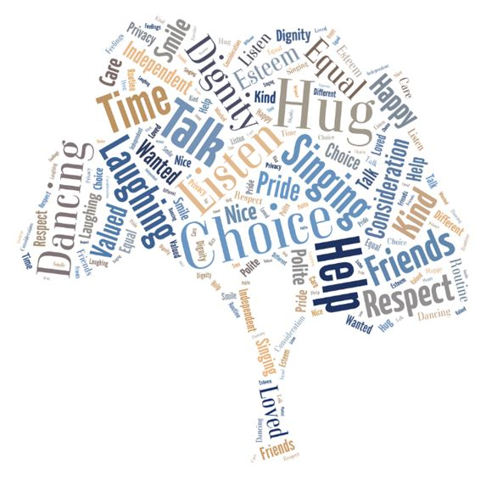

We want you to stay involved with the Derby and Derbyshire Dignity Campaign and to play your part in contributing to a genuinely improving culture of dignity in services across Derby and Derbyshire. We hope you will want to renew your award and make further progress.

Each time a team gains or renews their Derby/Derbyshire Dignity Award they become award holders for up to 2 years (whichever renewal option chosen below).

N.B. Non- renewal requires the holder to remove any certificates or advertising about holding the award and removal from the dignity website.

We welcome reinstatement which is via a successful full new application.

Your team has two options how to renew your Dignity Award:

OPTION 1

You can renew once only via Option 1. It offers further thinking time as you move to option 2. This involves your team reviewing your original successful award application based on the national 10 point dignity ‘do’s’. It requires reflection on changes you have made since achieving the award (the plans you have highlighted in question 4 on each standard)

We encourage you to look for an emerging piece of work, ready next time for Option 2.
Option 1 details are at page 2 below.

OPTION 2

Option 2 involves a Piece of Work which permanently improves the experience of dignity for people who receive your service. It is something created by your team which will not only benefit people who have your service but will also offer inspiration to other service providers in the City and/or County who may ask you to share your ideas. Future renewals will be every two years showing continuous initiatives which will contribute further to an accessible stock of high quality work in the City and/or the County and reflect team-level continuing professional development.

Option 2 details are at page 4 below.

HOW TO SEND COMPLETED RENEWALS

- Email to Sana.farah@derby.gov.uk

Unsure about anything? Contact Sana, named above, who will find you an answer

OPTION 1

Please read the guidance highlighted in yellow below then delete as you go.

SERVICE NAME AND ADDRESS:

(It is helpful to give a couple of sentences about the service you provide. This helps the assessors’ understanding)

SERVICE CONTACT:

(We keep in touch occasionally with service contacts and in due course we send them renewal reminders)

Name(s):

Designation:

E-mail:

Telephone:

Date Sent:

A Dignity Champions: Please list your team dignity champion(s) whose names are registered on the national dignity website.
Names

Team manager must be registered; even better if more/all the team are registered..

Say briefly what local dignity champions do/ how they are supported

You can choose to provide details requested above about your service; service contacts and dignity champions etc. on this format information but, if you prefer, you can add this as a front sheet to your renewal described in section B.

B Further Action since Achieving the Dignity Award
Look at your original application. Please make sure you give an update on action points you listed in your original application in question 4 (the plans you have highlighted in question 4 on each standard)

Using the correct application form, add to it in a different font and/or font colour so the updates are clear to see.

Written evidence is assessed, same as for your original award so full evidence please with examples.

Also explain general improvements you have made with a genuine thoughtful narrative.

When you want to move on via Option 2, no need to wait until award expiry time. Just go for it!

OPTION 1: SEND THIS IN WITH YOUR UPDATED APPLICATION. DETAILS BELOW

OPTION 2
Please read the guidance highlighted in yellow below then delete as you go.

First download a copy of this document from the website. As you complete it boxes expand to content.

SERVICE NAME AND ADDRESS:

(It is helpful to give a couple of sentences about the service you provide. This helps the assessors’ understanding)

SERVICE CONTACT:

We keep in touch occasionally with service contacts and in due course we send them renewal reminders)

Name(s):

Designation:

E-mail:

Telephone:

Date Sent:

A Dignity Champions: Please list your team dignity champion(s) whose names are registered on the national dignity website.
Names

Team manager must be registered; even better if more/all the team are registered..

Say briefly what local dignity champions do/ how they are supported

B Description: Please outline - within 300 words - your piece of work
No need to send in full evidence - just make clear you are ready for an assessment site visit.

What your piece of work is about; Who it involves; what it is achieving

Brief outline of process gone through to get up and running e.g. consultation/ testing / modification.

The site visit is an opportunity to show your piece of work to a health or social care professional like yourself who is keen to know more.

Option 2 renewal piece of work can also promote allied initiatives e.g. the Social Care Commitment; Quality Always; National Pensioners Dignity Code; Care Makers etc.

C The National 10 Point Challenge: Linking To What You Do
Choose one or more point from the national 10 point challenge which your piece of work promotes especially well and explain briefly why.

Please make sure you can give an update on action points you listed in your original application

D Customer Involvement: Describe ‘customer’ involvement in your piece of work
Your piece of work should involve the ‘customer’ to ensure the idea is a good one and maybe add their ideas too.

How were they involved in this piece of work

E Involvement of frontline staff: Describe frontline staff involvement in your piece of work
Your piece of work should involve/be ‘owned’ by all the team
Explain how all the team been involved in the piece of work.

F Sustainability: Explain why you are confident that your piece of work will continue and develop further?
How your piece of work has embedded into everyday practice and will continue.

G Results: Please show real evidence of positive results for the people receiving the service and (where appropriate) their carers
Positive results are the key test - real evidence of the benefits you have created
e.g. management information; individual stories; rooms; video; display boards and/or computers etc. available when the assessor visits.

To renew in 2 years’ time you will need to:

Demonstrate that your service has continued to make significant improvements of dignity and respect for your “customers”

This will be assessed by a further visit to your establishment which will look at the evidence of this.

PLEASE SEND YOUR RENEWAL TO US

- Preferably email to Sana.farah@derby.gov.uk

Unsure about anything? Contact Sana, named above, who will find you an answer

